**Django Structure**

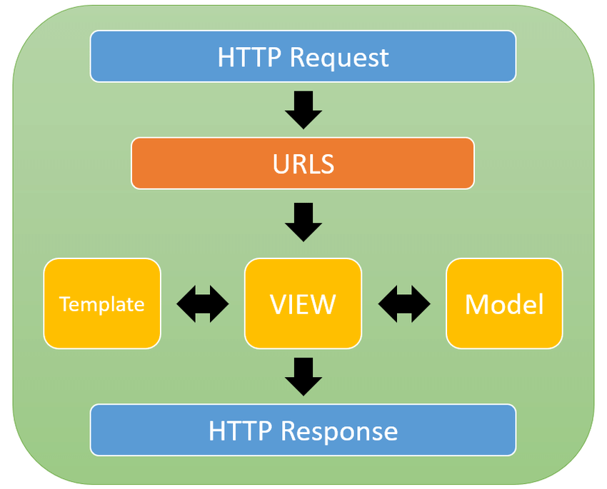

**Database set up**

1. Create a new Django Project
2. Create a new application
3. Go to models.py to create database tables

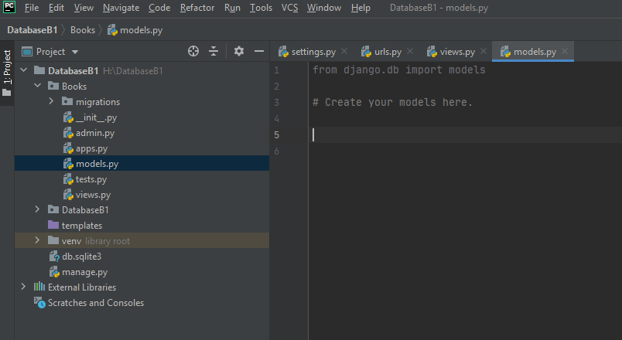

Simple Book table

| ID (PK) | Book Title (String) | Author Name (String) | Price (Integer) |
| --- | --- | --- | --- |
| 1 |  |  |  |
| 2 |  |  |  |

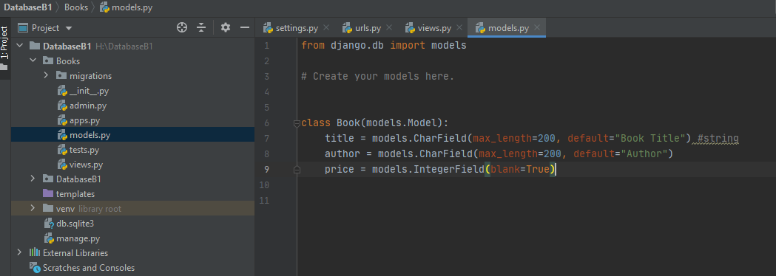

1. Install the new app

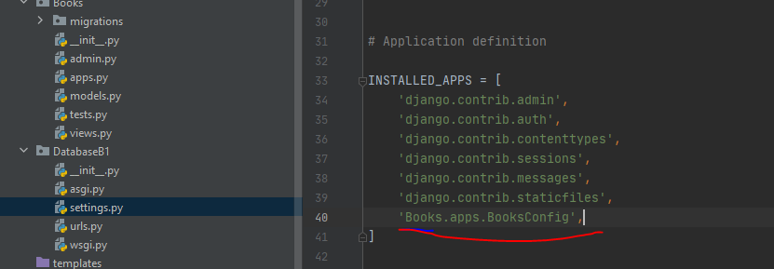

1. python manage.py makemigrations

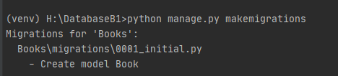

1. python manage.py migrate

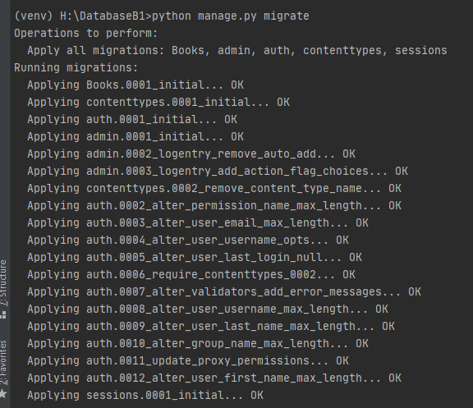

1. Python manage.py createsuperuser

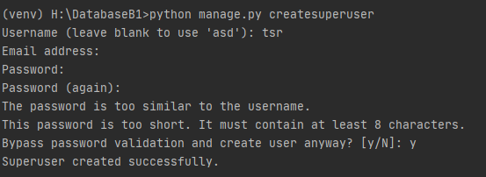

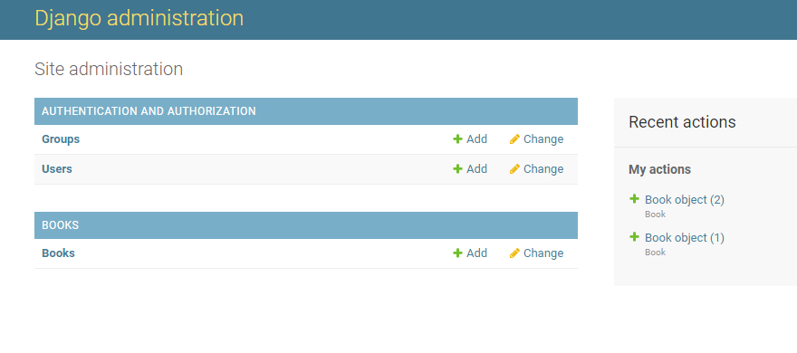

1. Register database table (model) in admin.py

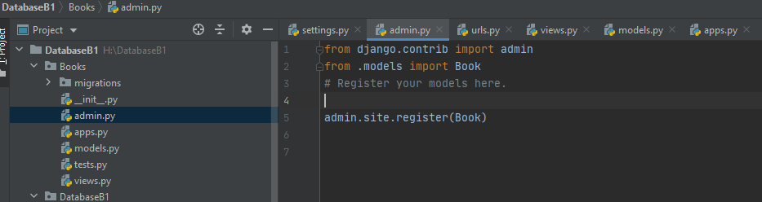

1. admin:



1. Create an empty HTML to show books from database

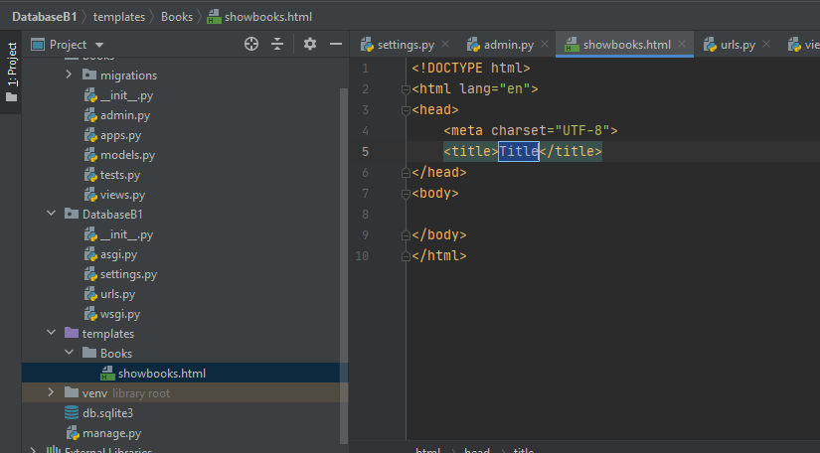

1. Connect this html page with views

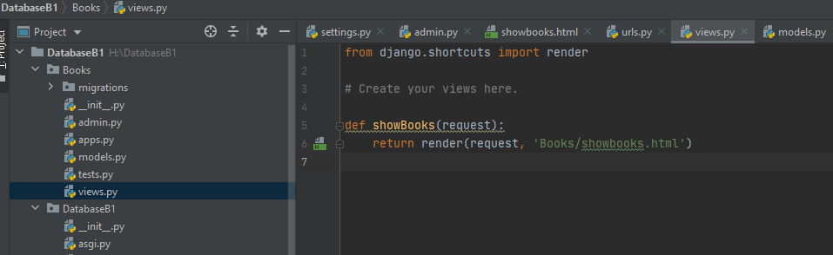

1. Connect Books->views with main->urls

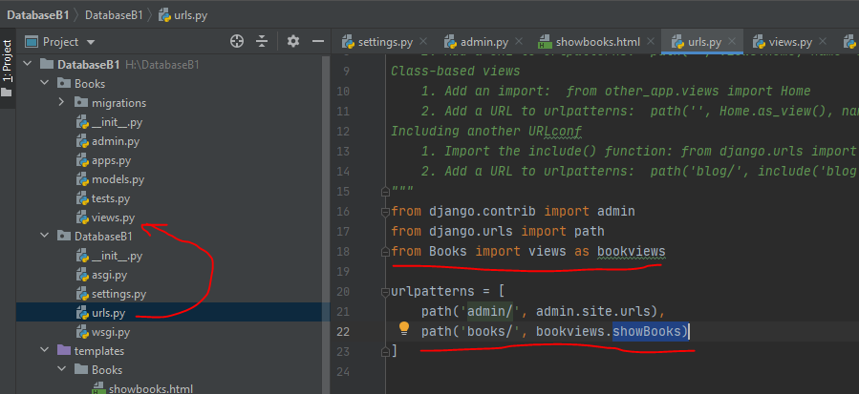

1. Views.py (controller). Get information from database

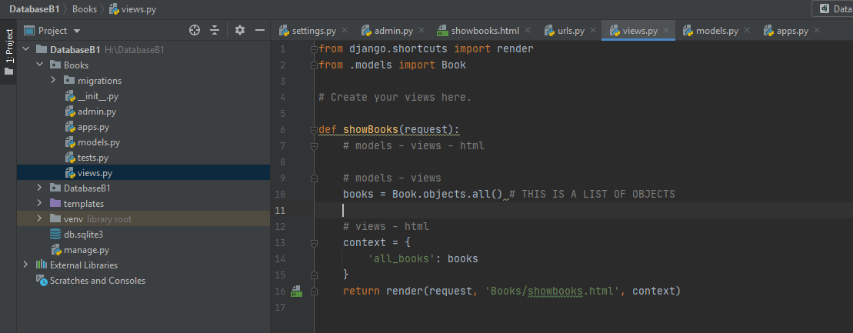

1. Showbooks.html (view)

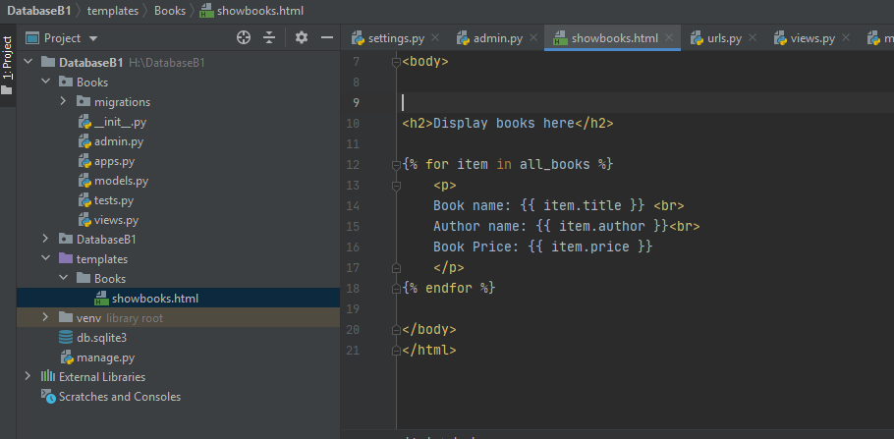

1. Display books

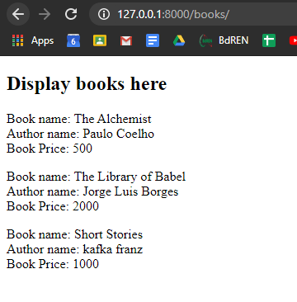

**Add information from HTML to DB**

I want to add information like admin

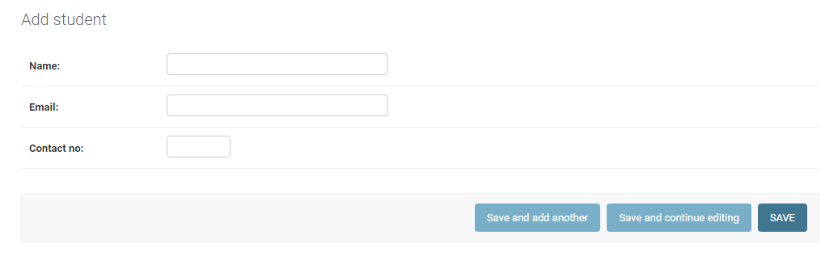

1. Create a new file name forms.py and add the codes like this

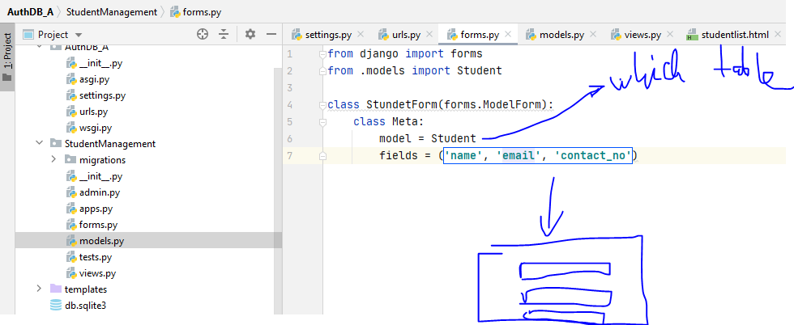

1. Views.py

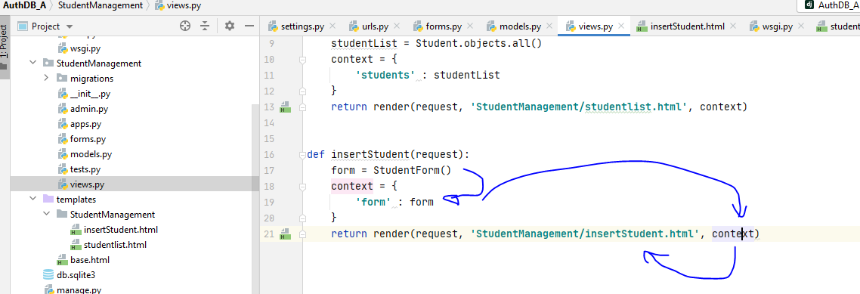

1. urls

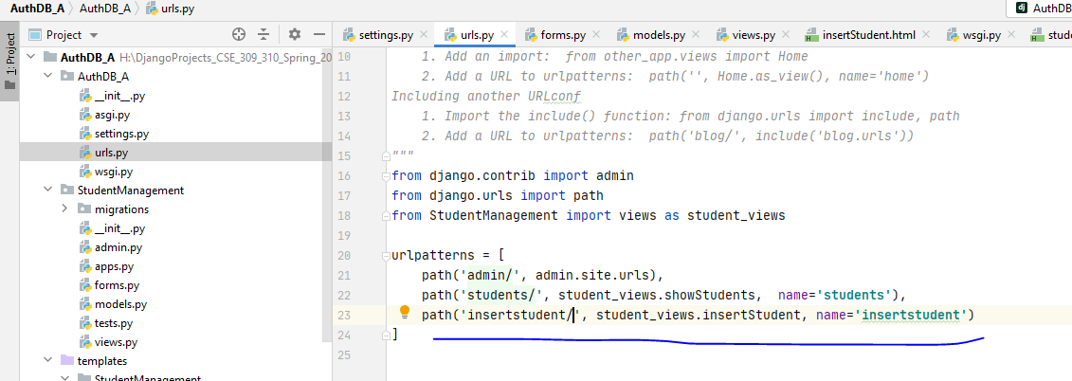

1. Html file

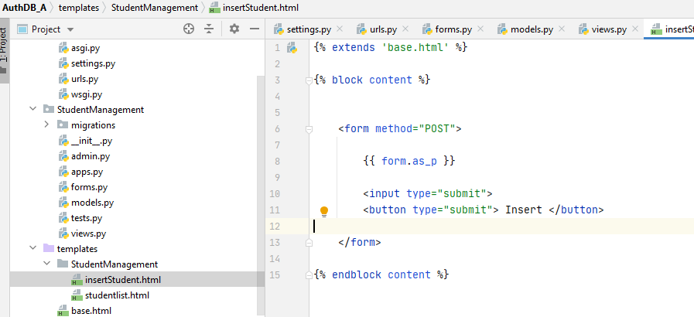

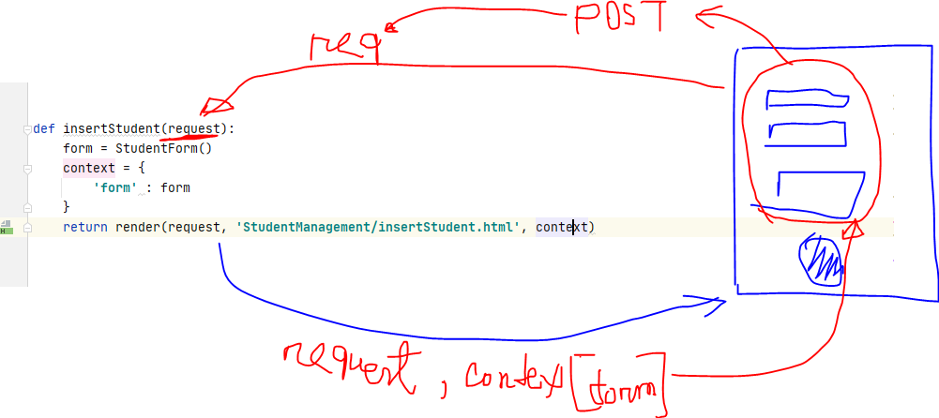

1. Save into database

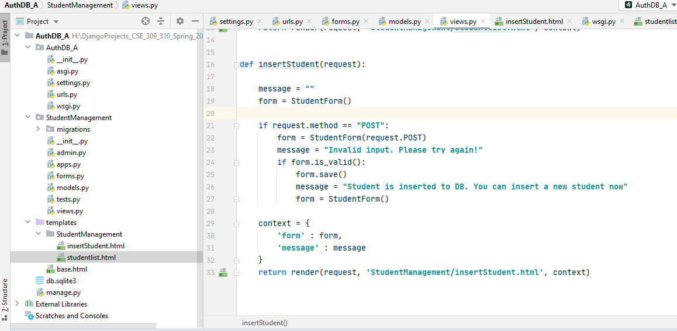

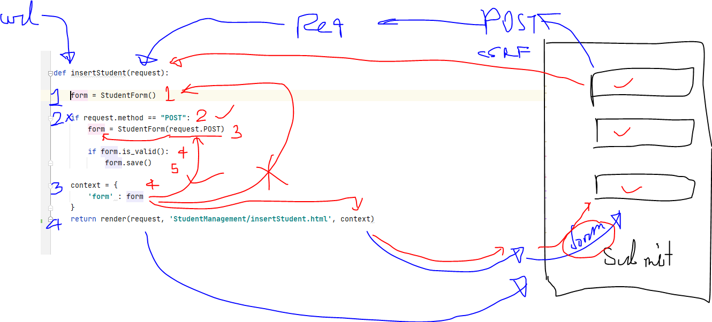

**Django Authentication**

1. **Create an User application**

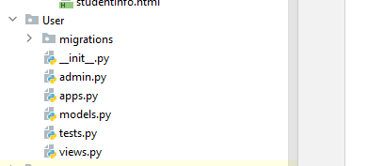

1. **Create a registration html**

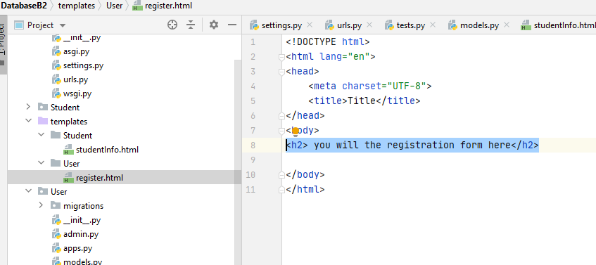

1. Create views for registration html page

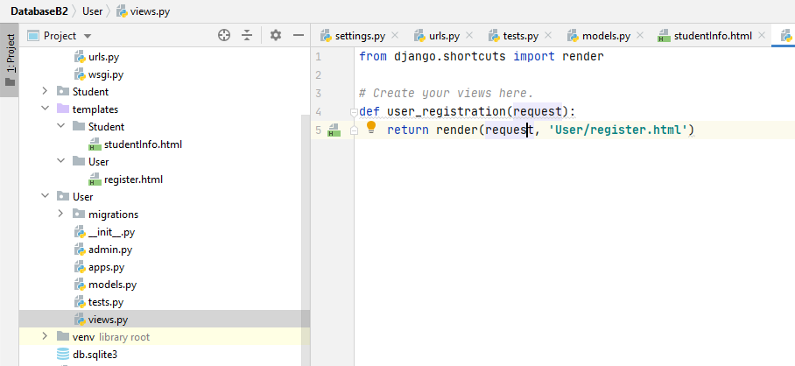

1. Connect views with main urls

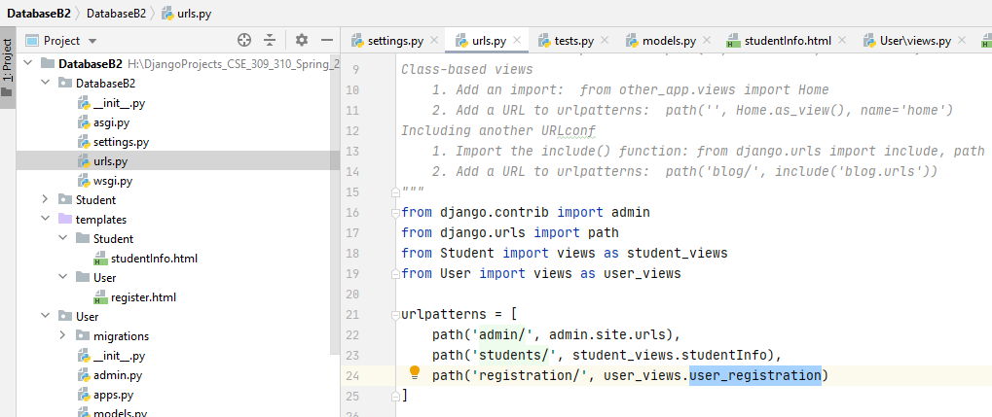

1. Runserver to check the page

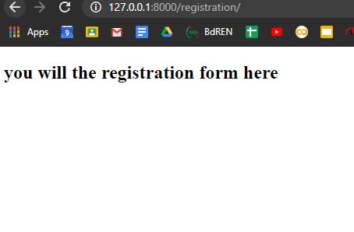

1. Import UserCreationForm in views.py

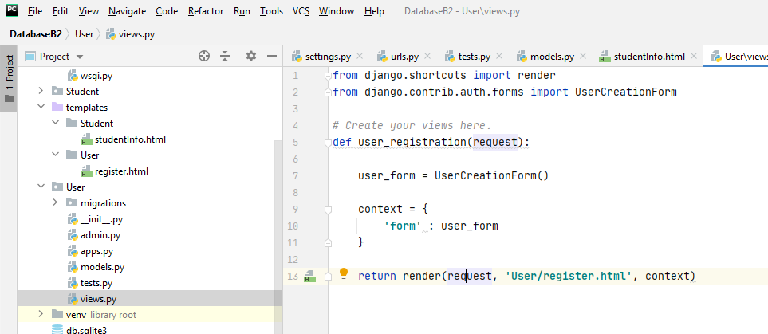

1. Add form in html page

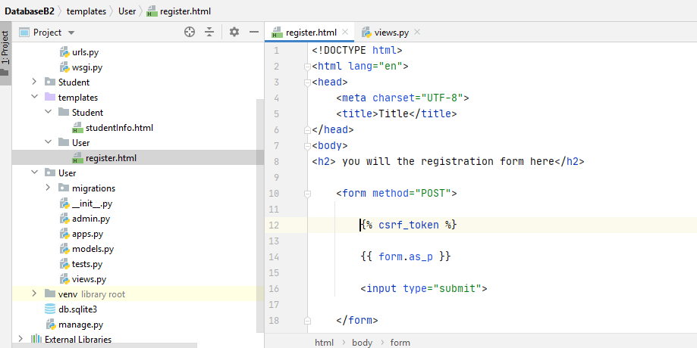

1. Handle POST request in the views.py

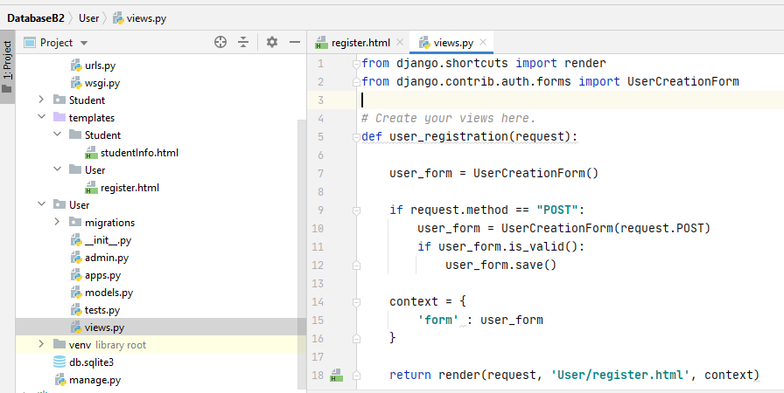

1. Go to registration page from server

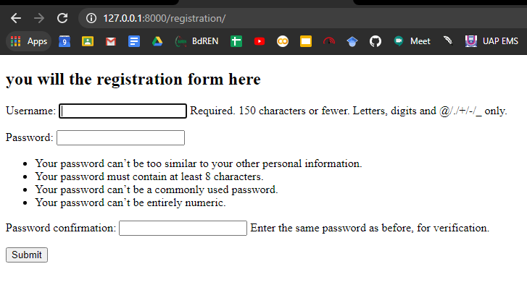

1. Submit information correctly

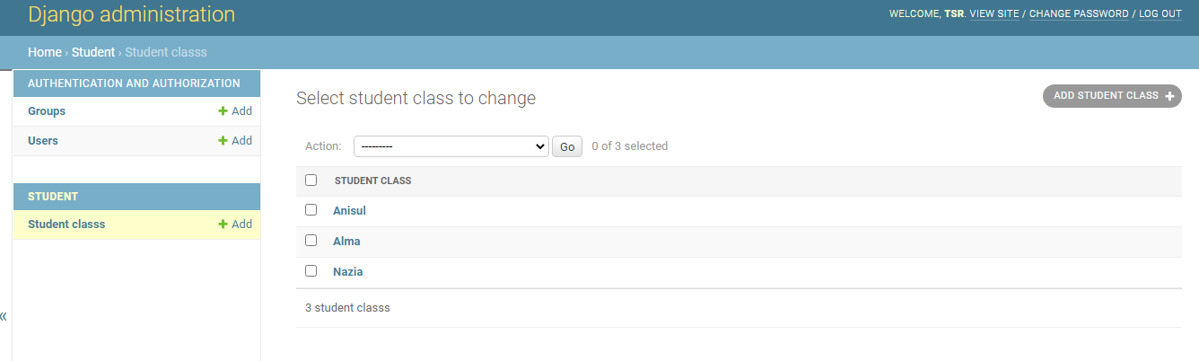

**Static**

